Assignment -1 Block chain

Step 1: Open Remix platform

Step 2: Open Remix Page

Step 3: Create New File
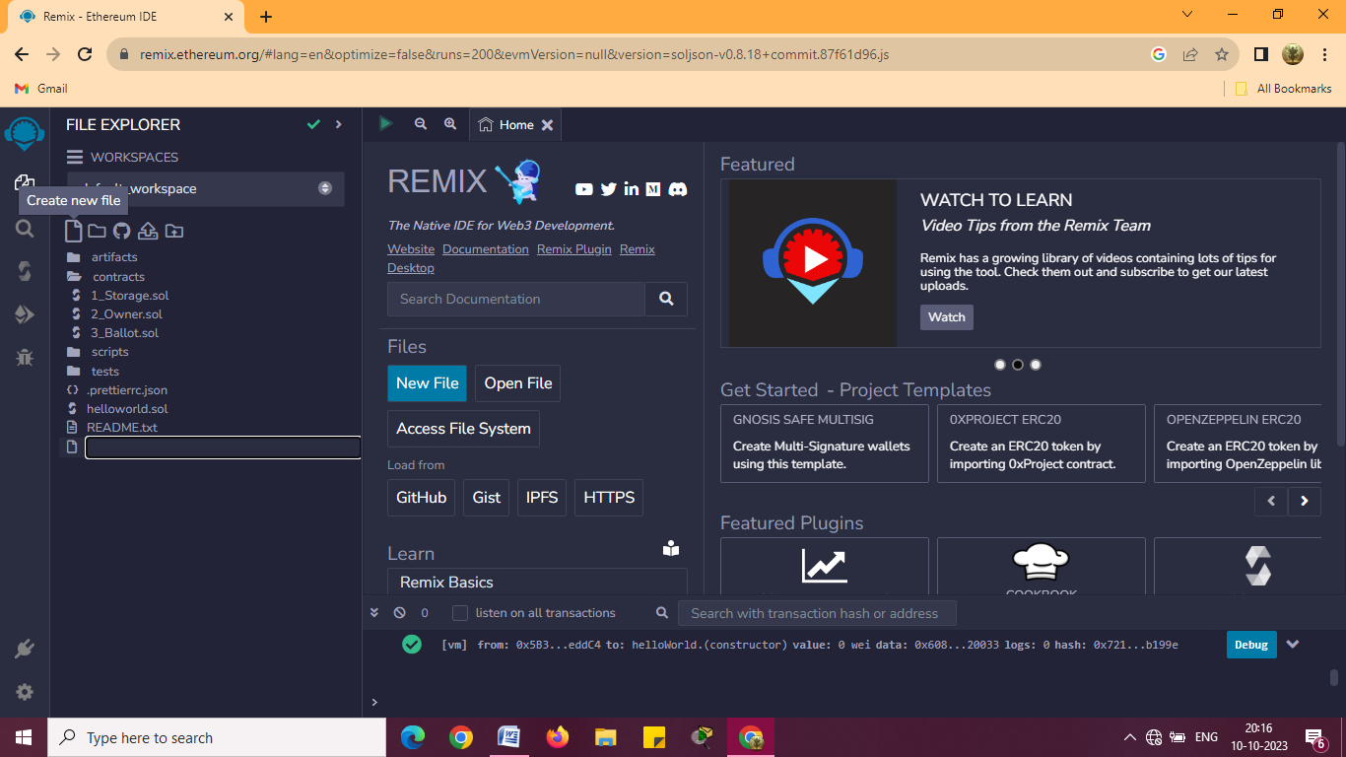

Step 4: String Program with Zone
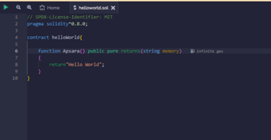

Compile:

ABI cipboard:

Bytecode clipboard:
Step 5: Deploy output
